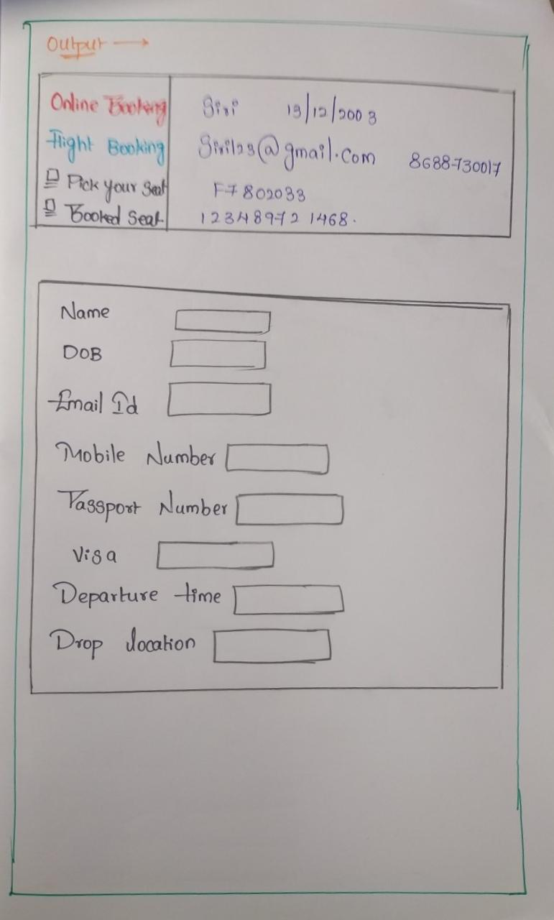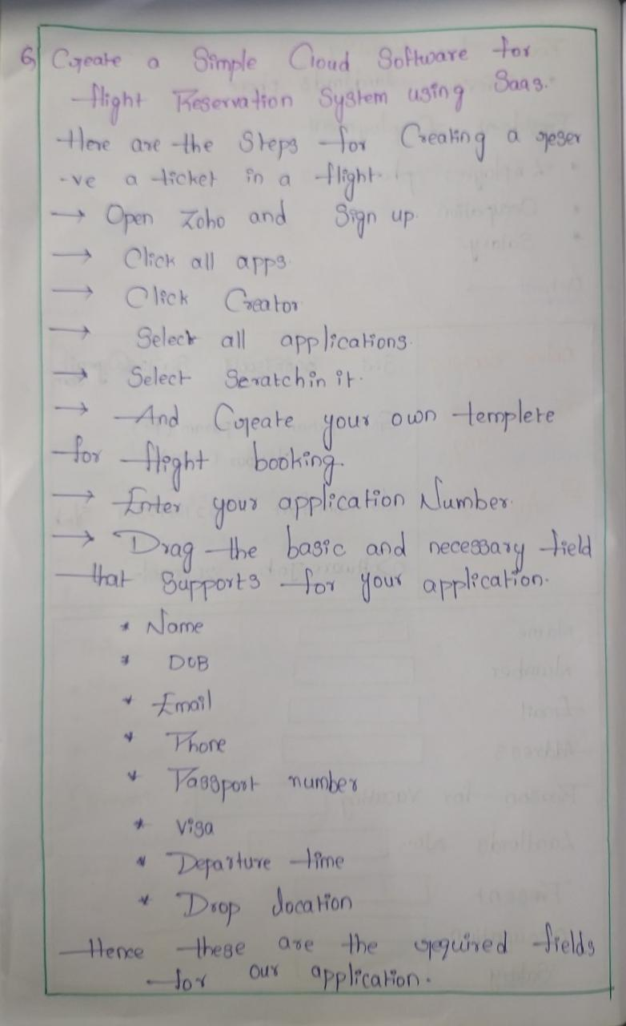**4.Create a simple cloud software application for Flight Reservation System using any Cloud Service Provider to demonstrate saas.**

